Memorandum Analyzing a Lab Report
Requirement:
- Polished, properly formatted, 2-page memorandum
- 12-point Times New Roman font
- Single-spaced lines
WHAT: Analyze a sample lab report provided by your instructor to determine the extent to which the lab report successfully accomplishes its required tasks. Then write your findings in a 2-page memorandum (memo) addressed to your course instructor.
HOW: This assignment is designed to familiarize you with basic elements of engineering and science lab reports and to teach you how to construct a memo for business use. Analyze the lab report provided by your instructor and then write a memo detailing your analysis. The final draft of the memo should include the following sections and information:
Heading: A standard memo heading section that contains To, From, Subject, Date.
Introduction: Begin the memo’s content section by clearly stating why the memo has been written and what topic the memo will discuss. This is an overview section and usually not more than two or three sentences in length.
Findings or Results: After analyzing the lab report, arrange your results so the most important points are discussed first in the memo. This will be the longest section of the memo and will likely require several clear and concise paragraphs. Here are some questions to consider as you determine the extent to which the lab report successfully accomplishes its required tasks:
Does the lab report
  - ▪  contain a complete cover page, abstract, and sections detailing the experimental
procedure, data/results, questions/discussion, conclusion?
  - ▪  clearly define its purpose?
  - ▪  clearly describe the problem that led to the lab experiment/test?
  - ▪  appear to clearly explain the lab experiment’s limitations?
  - ▪  discuss any theory necessary for a reader to understand the lab experiment/test and lab report findings?
  - ▪  describe the apparatus used to collect data for the lab report?
  - ▪  describe the procedure used to collect data for the lab report?
ENG
▪ clearly provide results of the lab’s experiment/test?
▪ appear to properly interpret the stated results of the lab’s experiment/test? ▪ appear to make proper conclusions from the interpretations?
▪ provide recommendations based on the lab report’s findings?
Conclusions and Recommendations: This section of the memo will state your most significant recommendations for improving the effectiveness of the lab report; this section will probably be a single paragraph in length.
This is the sample memo 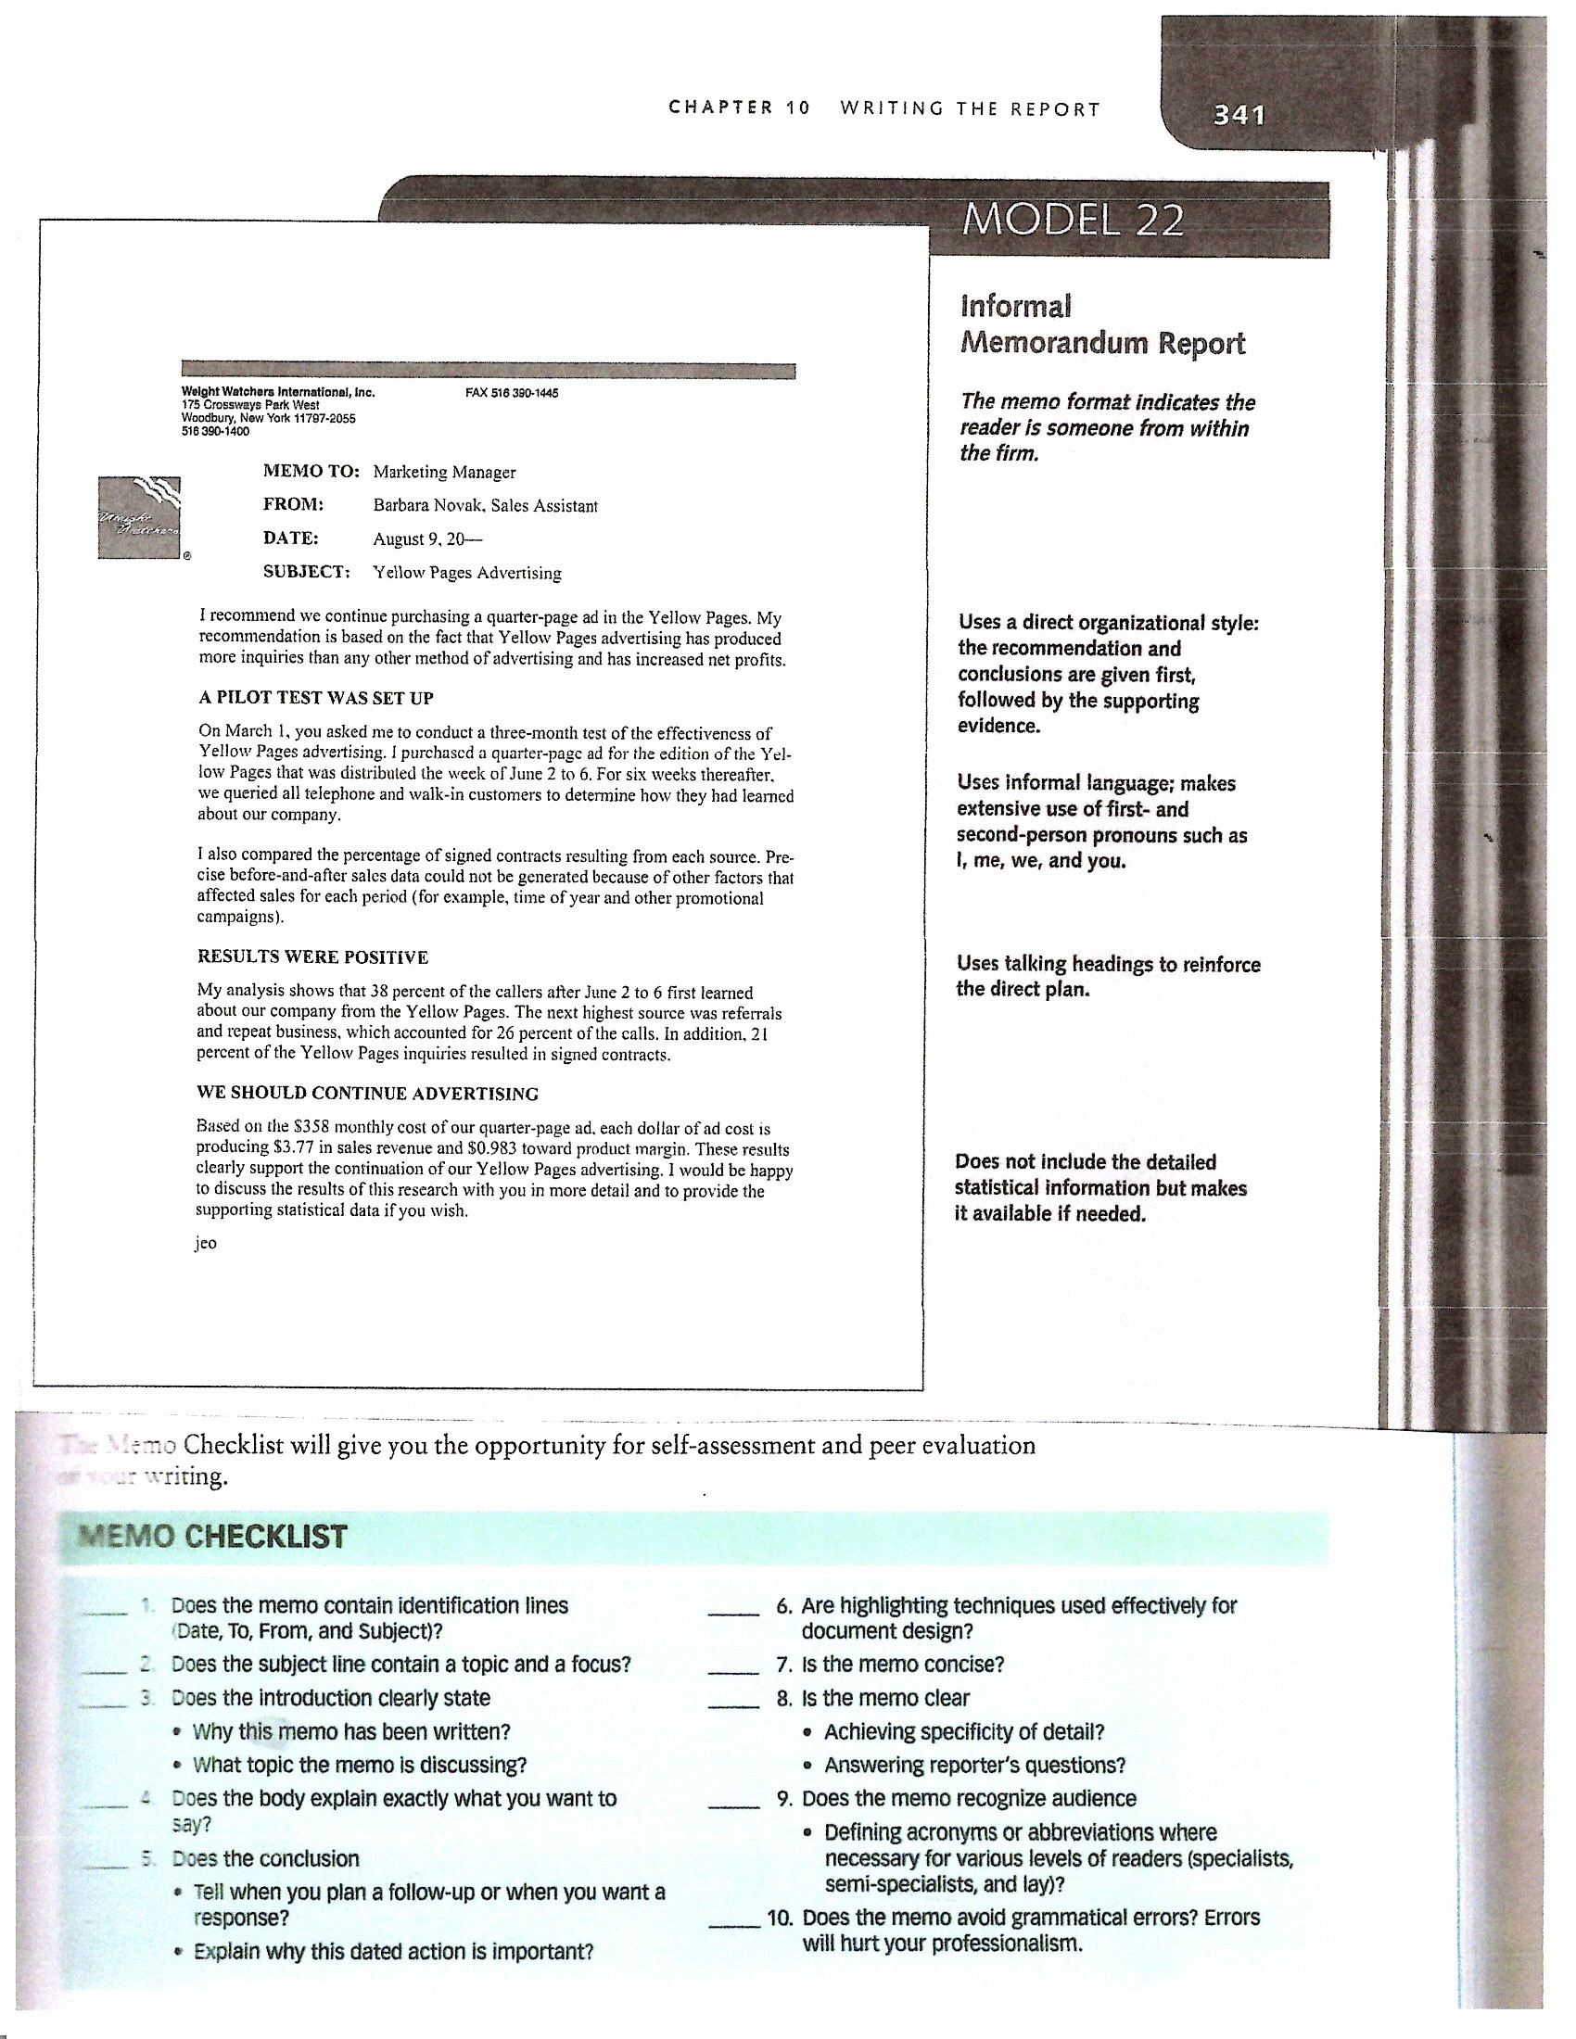

2: Memorandum
Assessment Worksheet

_____ Memo contains required identification lines (up to .25 points possible)

_____ Subject line contains a topic and a focus (up to .25 points possible)

_____ Introduction clearly states (up to 2 points possible)
_____ Why memo has been written
_____ What topic memo is discussing

_____ Body answers questions posed by the class published assignment description (up to 4 points possible)
_____ Does lab report have cover page?
_____ Does lab report have abstract?
_____ Does lab report have sections detailing the experimental procedure, data/results, questions/discussion, conclusion?
_____ Does lab report clearly define its purpose?
_____ Does lab report clearly describe the problem that led to the lab experiment/test?
_____ Does lab report appear to clearly explain the lab experiment’s limitations?
_____ Does lab report discuss any theory necessary for a reader to understand the lab experiment/test and lab report findings?
_____ Does lab report describe the apparatus used to collect data for the lab report?
_____ Does lab report describe the procedure used to collect data for the report?
_____ Does lab report clearly provide results of the lab’s experiment/test?
_____ Does lab report appear to properly interpret the stated results of the lab’s experiment/test?
_____ Does lab report appear to make proper conclusions for the interpretations?
_____ Does lab report provide recommendations based on the lab report’s findings?

_____ Conclusion (up to 1 point possible)
_____ Tells when memo’s author plans to follow up or when he/she needs response and explains why dated action is important
(Might also serve as location for memo’s recommendations.)

_____ Highlighting techniques used effectively in document design (up to .25 points possible)

_____ Memo is concise (up to .25 points possible)

_____ Memo is clear (up to .25 points possible)

_____ Memo recognizes its audience (up to .25 points possible)

_____ Memo is free of all grammatical and punctuation errors (up to 1.5 points possible)

